The following is the Power Magazine article I spoke from at CIBO in Kingsport. I found it timely and a perfect example of the precursors to potential power shortages and wildly high electric rates we will see in the US if we do not get our collective act together. Permitting, forced retirements, energy policy (or the lack thereof), local & national politics, fuel availability, environmental concerns and economic growth and survival all depend on us figuring this out together, or failing as a nation. The infrastructure of today is not going to be adequate in 5- 10 years. Let’s get this done with groups like CIBO advocating for smart change and growth ASAP.

Bob Langstine – Zeeco, Inc.

[PJM Capacity Auction Prices Surge Over Nine-Fold, Signal Urgent Need for New Power Generation](https://www.powermag.com/pjm-capacity-auction-prices-surge-over-nine-fold-signal-urgent-need-for-new-power-generation/)

—***Sonal Patel****is a POWER senior editor (*[*@sonalcpatel*](https://twitter.com/Sonalcpatel)*,*[*@POWERmagazine*](https://twitter.com/POWERmagazine)*).*

**Fold, Signal Urgent Need for New Power Generation**

Prices at PJM Interconnection’s 2025/2026 base residual auction (BRA) spiked to $269.92/MW-day for most resources in the wholesale power market, pointing to a tightening supply-demand balance that could have significant implications for the regional transmission organization (RTO).

The 2025/2026 BRA—a competitive capacity auction that procures power supply resources in advance of the delivery year to meet demand in the region’s 13-state footprint—procured 135,684 MW from June 1, 2025, through May 31, 2026, PJM [said on July 30](https://www.prnewswire.com/news-releases/pjm-capacity-auction-procures-sufficient-resources-to-meet-rto-reliability-requirement-302210332.html). Additionally, the total Fixed Resource Requirement (FRR) obligation—where an eligible load-serving entity meets fixed resource requirements with their own capacity resources—added another 10,886 MW.

Combined, the auction and FRR commitments totaled 146,570 MW, representing an 18.5% reserve margin—only slightly above PJM’s 17.8% target reserve margin but notably lower than the 20.4% reserve margin procured for the 2024/2025 delivery year year, PJM said.

The auction cleared a diverse mix of resources: 48% gas, 21% nuclear, 18% coal, 1% solar, 1% wind, 4% hydro, 5% demand response, and 2% from other sources. However, two zones—BGE in Maryland and Dominion in Virginia—“cleared just short of their reserve requirement, resulting in prices being set at the zonal cap.” Prices at BGE soared to $466.35, while Dominion reached $444.26.

“This is due to insufficient resources inside those regions and constraints on the transmission system that limit the ability to import capacity,” PJM explained. “These prices indicate that those regions would benefit from either additional resources, additional transmission to allow increased imports into those regions or a combination of the two.”

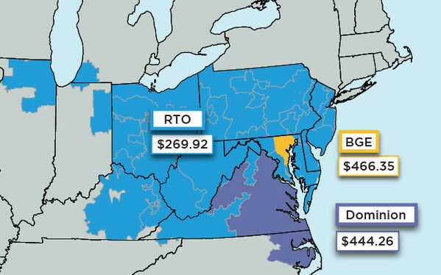*PJM Interconnection’s 2025/2026 Capacity Prices. Courtesy: PJM Interconnection (July 30, 2024)*

**Results Point to a Dire Need for Investment in New Generation**

While the RTO’s capacity market—or [Reliability Pricing Model (RPM)](https://learn.pjm.com/three-priorities/buying-and-selling-energy/capacity-markets.aspx)—is just one of several wholesale power markets PJM manages, the BRA functions as a bellwether for future investment needs, grid reliability, and the overall health of the power supply system in the region.

In a nutshell, compared to PJM’s [day-ahead and real-time](https://www.pcienergysolutions.com/2023/10/18/day-ahead-vs-real-time-market-whats-the-difference/#:~:text=As%20the%20name%20implies%2C%20the,and%20the%20seller%20must%20sell.) energy markets, the RPM ensures long-term grid reliability by securing future capacity—the appropriate power of power supply resources necessary to satisfy predicted energy demand typically three years into the future. The BRA essentially allows PJM to procure resource commitments to satisfy the region’s unforced capacity obligation for a capacity delivery year (this auction’s period spans June 1, 2025, to May 31, 2026).

As a whole, in each BRA, PJM aims to procure a target capacity reserve level for the RTO in a “least-cost” manner while also taking into account reliability-based constraints on the location and type of capacity that can be committed. PJM allocates the cost of those commitments to load-serving entities (like NRG Energy or Vistra) through a locational reliability charge, which is then paid to power supply resources for performance. The total cost for the 2025/2026 BRA was $14.7 billion, PJM said on Tuesday.

BRA auctions are usually held three years in advance of the delivery year. While the 2025/2026 auction was originally scheduled to be held in May 2022, it was suspended while the Federal Energy Regulatory Commission (FERC) considered the approval of new capacity market rules. The recent July 2024 auction stems from a compressed schedule that aims to return to the three-year forward basis. According to PJM, the next BRA—for the 2026/2027 delivery year—is scheduled for December 2024.

But compared to previous auctions, the 2025/2026 auction results point to several concerning trends. “The significantly higher prices in this auction confirm our concerns that the supply/demand balance is tightening across the RTO,” noted PJM President and CEO Manu Asthana. “The market is sending a price signal that should incent investment in resources.”

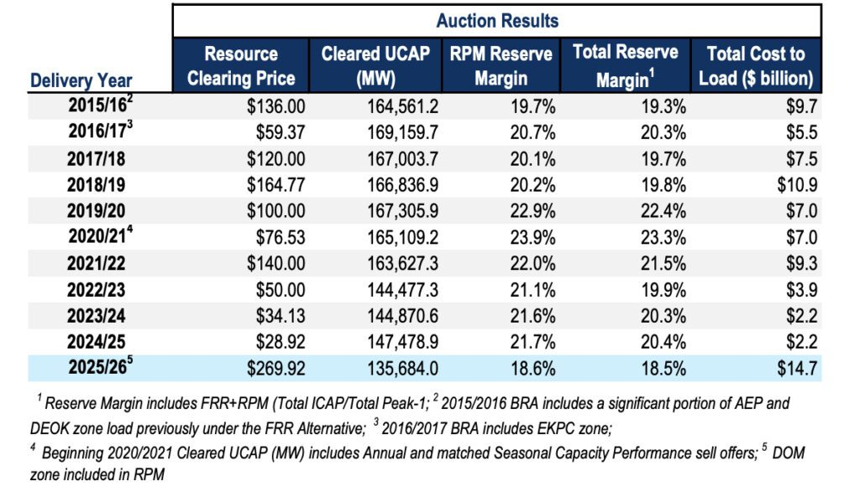  
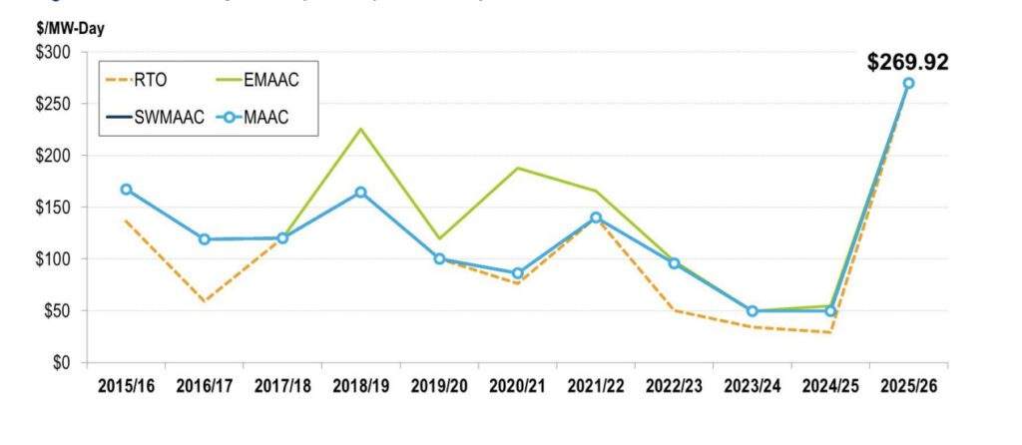*Clearing price results in PJM’s Base Residual Auction (BRA) from delivery year 2015/2016 to 2024/2025.*[*Courtesy: PJM*](https://pjm.com/-/media/markets-ops/rpm/rpm-auction-info/2024-2025/2024-2025-base-residual-auction-report.ashx)

**Surge in Prices Driven by Retirements, Soaring Demand, Market Reforms**

PJM noted that the surge in prices across most of its footprint is driven prominently by “decreased supply offers into the auction,” mainly “due to generator retirements.” About “6,600 MW of generation have retired or have must-offer exceptions (signaling intent to retire) compared with the generators that offered in the 2024/2025 BRA,” it said.

Meanwhile, PJM said the 2025/2026 BRA procured only 110.3 MW of capacity from new generation and 753.8 MW from uprates to existing or planned generation. “The quantity of new generation is down from the previous BRA where there was 328.5 MW of new generation,” it said.

Auction prices were also pushed higher by an increase in projected peak load, PJM said. Peak load forecast for the 2025/2026 delivery year surged upwards to 153,883 MW, compared to  150,640 MW for the 2024/2025 BRA, it noted.

In addition, the entity pointed to impacts from recent market reforms approved by the FERC. These include “improved reliability risk modeling for extreme weather and accreditation that more accurately values each resource’s contribution to reliability,” it said.

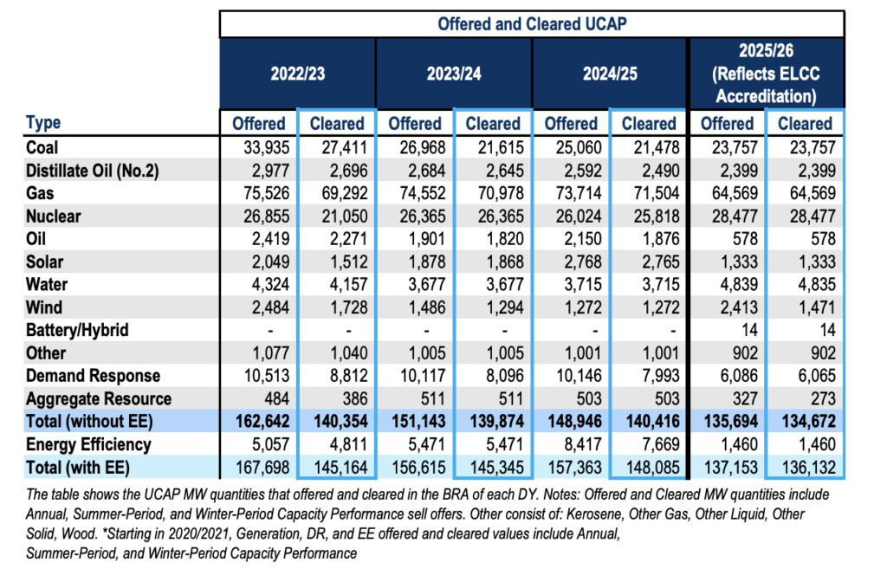*Offered and cleared megawatts by type for Reliability Pricing Model (RPM) and committed Fixed Resource Requirement (FRR) for the current and previous base residual auction. Courtesy:*[*PJM*](https://pjm.com/-/media/markets-ops/rpm/rpm-auction-info/2025-2026/2025-2026-base-residual-auction-report.ashx)

**A Key Worry: Fourth Year in a Row Where Supply Resources Fell**

A more concerning factor for the RTO is that this year the amount of supply resources in the auction fell yet again this year. As the [RTO’s report shows](https://pjm.com/-/media/markets-ops/rpm/rpm-auction-info/2025-2026/2025-2026-base-residual-auction-report.ashx), supply offered into the RPM capacity market declined by more than 13 GW, falling to 135,692.3 MW in the 2025/2026 BRA. That compares to 148,945.7 MW of supply offered in the 2024/2025 BRA.

“This is the fourth BRA in a row where the total capacity offered from non-[energy efficiency (EE)] resources has declined,” the report notes. In addition, the number of constrained Locational Deliverability Areas (LDAs) dropped from five to two in the 2025/2026 BRA. “The total amount of capacity, excluding EE Resources, in RPM that cleared decreased by 5,743.6 MW from 140,415.8 MW in the 2024/2025 BRA to 134,672.2 MW in the 2025/2026 BRA,” it said.

The auction results add new weight to PJM’s long-voiced concerns about its supply-demand balance, which it says have grown more precarious as resource retirements and load growth exceed the pace of new generation entry.

In a [much-cited study](https://www.pjm.com/-/media/library/reports-notices/special-reports/2023/energy-transition-in-pjm-resource-retirements-replacements-and-risks.ashx) published in February 2023 exploring “a range of plausible scenarios up to the year 2030,” PJM suggested that as much as 40 GW of existing generation is at risk of retirement by 2030. “This figure is composed of 6 GW of 2022 deactivations, 6 GW of announced retirements, 25 GW of potential policy-driven retirements, and 3 GW of potential economic retirements. Combined, this represents 21% of PJM’s current installed capacity,” it warned.

“The amount of generation retirements appears to be more certain than the timely arrival of replacement generation resources and demand response, given that the quantity of retirements is codified in various policy objectives, while the impacts to the pace of new entry of the Inflation Reduction Act, post-pandemic supply chain issues, and other externalities are still not fully understood,” PJM said in the 2023 report.

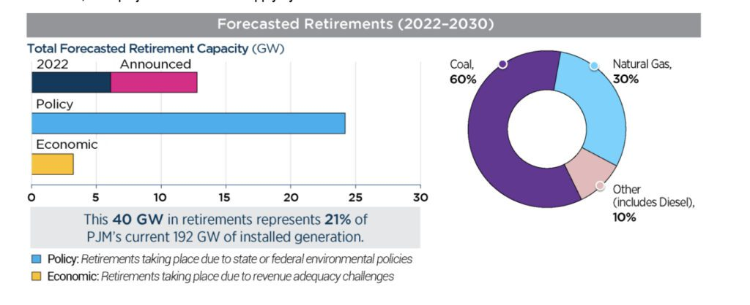*PJM forecasts a 40 GW demand increase over the next 15 years due to electrification and large new loads, such as data centers. But it also faces retirements that amount to 40 GW of generation by 2030. New generation projects face delays from supply chain, financing, and siting issues. “If this sluggish pace of development continues, PJM projects a shortfall in supply by the end of this decade—or sooner,” the entity has said. Courtesy: [PJM](https://www.pjm.com/-/media/about-pjm/ensuring-a-reliable-energy-transition/fact-sheet-for-policymakers.ashx)*

On Tuesday, the RTO underscored that reliability concerns are already endemic to most of the North American bulk power system (BPS). Those concerns have been [echoed by other RTOs](https://www.powermag.com/miso-warns-immediate-and-serious-challenges-are-threatening-reliability/) and the North American Electric Reliability Corp. (NERC), the BPS’ reliability watchdog. Earlier this year, [NERC outlined eight critical factors](https://www.powermag.com/eight-critical-reliability-challenges-nerc-is-confronting-for-grid-stability/) that are posing new hurdles for modern power systems, given what it calls a  “hypercomplex” risk environment.

PJM noted it had taken measures to facilitate the entry of new resource entries, including to implement [FERC’s recent generation interconnection reform](https://www.powermag.com/ferc-adopts-historic-reforms-to-ease-nationwide-generation-interconnection-backlog/). But while PJM expects about 72,000 MW of resources will be processed in 2024 and 2025 as a result of the reform, it said it remained concerned “with the slow pace of new generation construction.”

So far, while less than half—about 38 GW—of these resources have already cleared PJM’s interconnection queue, they “have not been built due to external challenges, including financing, supply chain and siting/permitting issues,” it noted.

“Interconnection process reform is proceeding, but hurdles remain for many projects outside of our process,” said Stu Bresler, PJM executive vice president of Market Services and Strategy, on Tuesday. “We are considering ways to accelerate those who can successfully overcome those challenges and build.”

**Competitive Generators Suggest Higher Prices a Good Sign**

While commentary is still trickling in, competitive generators that participate in the organized wholesale market generally viewed higher prices signaled by Tuesday’s auction as promising.

“While there is still work to be done, these price signals recognize the situation PJM faces and should begin to incentivize the investment needed to deliver a reliable system in PJM and in other U.S. markets,” said Todd Snitchler, president and CEO of the Electric Power Supply Association (EPSA), a national trade group representing competitive generators.

“Reliability watchdogs, regulators, policymakers, and PJM itself have been sounding the alarm that the misalignment of power resource retirements and additions poses a serious reliability risk to the grid—especially in the face of rising demand spurred by data center and manufacturing growth among other factors like electrification, extreme weather, and policy choices,” he added. “While encouraging, the results of one auction do not establish a trend; however, this auction does suggest that the initial market reforms instituted by PJM to address the misalignment issue had a positive impact.”

When working as designed, “competitive electricity markets are the best mechanism to maintain reasonable wholesale power costs while facilitating the entry of new, innovative technologies,” Snitchler explained. “Adequate compensation, however, is required for the resources that keep the lights on to be available when they are needed. A reliable system isn’t free, but competitive electricity markets continue to remain the best means to deliver a reliable power system without unduly burdening customers with unnecessarily higher costs,” he said.

PJM, however, indicated much more work lies ahead. Along with efforts to accelerate the development of new generation to replace retiring capacity, steps it highlighted in its [auction analysis](https://pjm.com/-/media/markets-ops/rpm/rpm-auction-info/2025-2026/2025-2026-base-residual-auction-report.ashx) include enhancing interregional transfer capabilities to improve reliability, addressing supply chain and financing challenges to facilitate project completion, and increasing collaboration with stakeholders to address emerging risks from new technologies and growing demand.

PJM suggests it will also work to address other shortcomings identified by the auction. The RTO on Tuesday noted that, as a whole, it failed the Three-Pivotal Supplier (TPS) Test (the Market Structure Test). The TPS is essentially used to evaluate local market power. The test ensures no single supplier can unfairly influence market prices, maintaining competitive market conditions. It assesses market share and participant interactions, serving as a crucial trigger for market power mitigation to balance structural market power and minimize unnecessary interventions. Failure of the test resulted “in the application of market power mitigation to all existing generation capacity resources,” PJM said. Mitigation was applied to “a supplier’s existing generation resources resulting in utilizing the lesser of the supplier’s approved Market Seller Offer Cap for such resource or the supplier’s submitted offer price for such resource in the RPM Auction clearing,” it explained.

—***Sonal Patel****is a POWER senior editor (*[*@sonalcpatel*](https://twitter.com/Sonalcpatel)*,*[*@POWERmagazine*](https://twitter.com/POWERmagazine)*).*